**Stellar Astrology - Gochara Results -**

**By Prof.C.S.Rao Astro Counselor**

**Gochara results** (Transit results)**:** Transit results are studied, in general, from Lagna or Chandra lagna or Sun lagna. Chandra lagna is the Sign where Moon is posited at the time of birth. Sun lagna is the Sign where Sun is posited in Birth Chart.

Moon is Manokaraka so counting from Chandra lagna is in wider practice for gochara results as we see daily / weekly / monthly / yearly forecasts in various journals- mostly in Vernacular languages.

* There are a good number of valid practices to assess transit results.
* In this article - it is chosen to assess the likely results of a transiting planet by gauging the *star -wise distance from birth star to the star* in which a transiting planet is moving.
* By this, the transit results are known for shorter periods - because we are considering the likely effects of every planet for a shorter period of its transit in 130.20’ instead of 300 of a Sign

**Technique involved in Gochara (Transit) Results**

* Birth chart is imbedded with a Static force with the static positions of planets at the time of birth.
* Influences of transiting planets are considered as a dynamic force on the static force imbedded in Birth chart.
* A widely accepted phenomenon for nearer to accurate predictions is by interpolating the Dynamic force on Static force points of birth chart.
* Sensitive Areas - Out of 360 degrees of Birth chart - only 21 degrees are sensitive - viz., 12 House Cuspal degrees plus 9 Planetary Cuspal degrees. -*Other degree points are also used in many other systems in the name of middle points, squares, grand squares etc.,*
* Sensitive Time : is the time of a transiting planet triggering the above 21 sensitive points. That is the time when a good or bad life event is likely to happen. So triggering time of every transiting planet is to be considered for a holistic approach.

**This Article - deals with the triggering of transiting planets on the birth time sensitive area of planets only and not of houses***.*

(Based on the Classical Vedic literature : Phaladeepika - by Mantreswara.)

**Main consideration -in this Article - is the Star wise transit theory** - thus the star wise distance of transiting planet to the natal position of Moon posited star ( i.e., birth star).

Two tables (A) and (B) are given below to arrive at the likely effects of each transiting planet.

**Contents of the Tables :** Following tables indicate the results of transit of a planet in different stars counted from birth star i.e., the Star-wise longitudinal distance.

**……….. Contd………..**

* **Table (A)**

1. Table (A) contains 6 columns -

* Col (1) indicates longitudinal distance - in terms of No.of Stars from birth star to the Star in which a transiting Planet (under study) is transiting.
* Col (2) to (6) are classified to indicate the different likely effects as per transiting Sun, Moon, Mars, Mercury, Jupiter, Venus, Saturn, Rahu and Ketu.

1. Table (A) is to be used to know the longitudinal distance (in terms of No.of stars) from the birth star to the star in which the transiting planet (under study) is transiting.

* **Table (B)**

1. Table (B) to be used - to identify the likely effects of the transiting planet under study - while it is transiting in any particular Star.

***Important:*** *Study the effects of each Transiting planet -Plants entry and exit time in a star is, always, to be noted to know the duration of likely results.*

********

**Guidelines- to use Table (A) and Table (B)**

*Study the effects of all planet transiting effects for a holistic approach***.**

**Step 1**- Select a No. in Col (1) of Table (A) - Count the number stars from birth star to the star in which the transiting planets is.

**Step 2** - As per the selected No. in Step 1 ( above) for the concerned planet under study pick up a number given in Col.(2) to Col.(6) of Table (A) - As per the Number so picked up go to the Table (B)

**Step 3.** As per the Number picked up in Step 2 above - Go to Table (B). Use that Number in Table (B) Col.(1) - against that in Col.(2) the Likely result is shown.

**Step 4 -** Interpolate “Likely transit result” shown in Step 3 - with the likely results of running D/B/A lords for final results.

**Step 5.** A holistic analysis of the Birth Chart is always essential.

**Step 6.** Finalize the observations with a priority for

1. Transiting bhava lords of bhva under study,
2. Running D/B/A lords,
3. Important transits like Sade Sati, Knataka Sani periods, transits of Rahu, Ketu
4. Transiting of 6/8/12 lords , Maraka and Bhadhaka lord etc., and
5. The age, sex, status and other relevant circumstances of the native.

*******

**Example:**

**Step 1**-For Transiting Sun - Find the star in which Transiting Sun is - Count the number of that star from Birth star.

**Step 2**- If Transiting Sun is in 5th star from birth star - No.16 is given under Col.(2) - So see the result in Table (B) against No.16 in Col (1) - The result Given in Col (2) is *“ Influence, increased earnings and Gains”*.

**Study for all planets in this way and examine cumulative results likely to occur. That is a holistic approach.**

**……….. Contd………..**

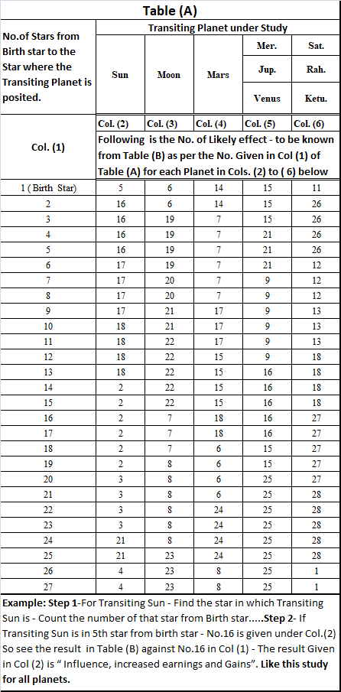

**……….. Contd………..**



